**Model Development Phase Template**

|  |  |
| --- | --- |
| Date | 09 July 2024 |
| Team ID | SWTID1720023141 |
| Project Title | Prediction and Analysis of Liver Patient  Data Using Machine Learning |
| Maximum Marks | 6 Marks |

**Initial Model Training Code, Model Validation and Evaluation Report**

The initial model training code will be showcased in the future through a screenshot. The model

validation and evaluation report will include classification reports, accuracy, and confusion

matrices for multiple models, presented through respective screenshots.

**Initial Model Training Code**

**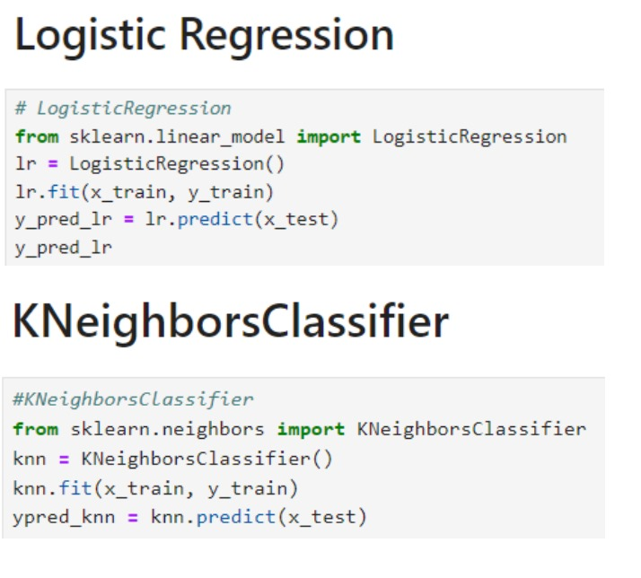**

**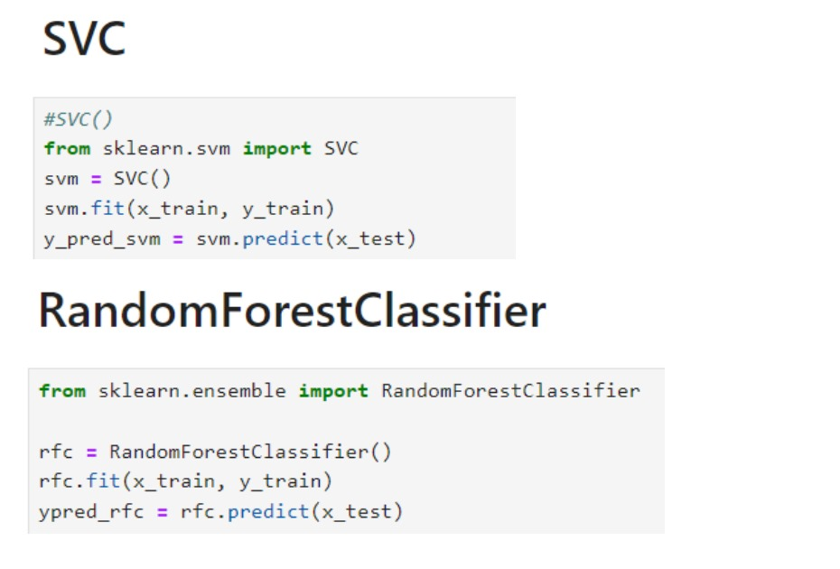**

**Model Selection Report:**

|  |  |  |  |
| --- | --- | --- | --- |
| **Model** | **Classification Report** | **Accuracy** | **Confusion Matrix** |
| Logistic  Regression | WhatsApp Image 2024-07-11 at 16.35.39_2ec0a445 | WhatsApp Image 2024-07-11 at 16.36.20_2cc8ea2b | **WhatsApp Image 2024-07-11 at 16.36.44_92bcce52** |
| K neighbors  Classifier | WhatsApp Image 2024-07-11 at 16.40.47_b0af0cff | WhatsApp Image 2024-07-11 at 16.40.54_35422ed6 | WhatsApp Image 2024-07-11 at 16.41.06_c5736102 |
| Random Forest  Classifier | **WhatsApp Image 2024-07-11 at 16.43.03_43a1c842** | **WhatsApp Image 2024-07-11 at 16.43.12_3eb9c671** | **WhatsApp Image 2024-07-11 at 16.43.24_a6c5bf5c** |
| SVC | **WhatsApp Image 2024-07-11 at 16.43.57_7f3ad193** | **WhatsApp Image 2024-07-11 at 16.44.10_f57063ae** | **WhatsApp Image 2024-07-11 at 16.44.24_926f8aca** |